**Struts 2 Tutorial 01 - Introduction To MVC**

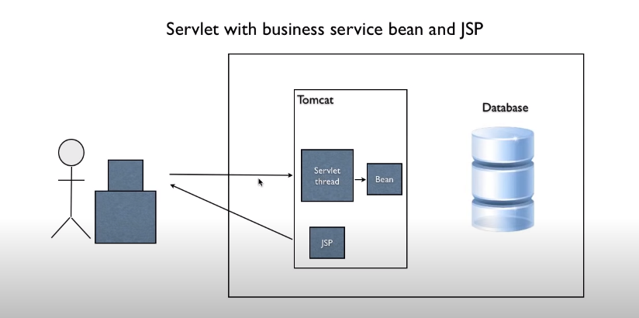<https://struts.apache.org/download.cgi#struts2525>

Download struts-2.5.25-all.zip and extract

Servlet (controller), Bean Service (model), Jsp (view)

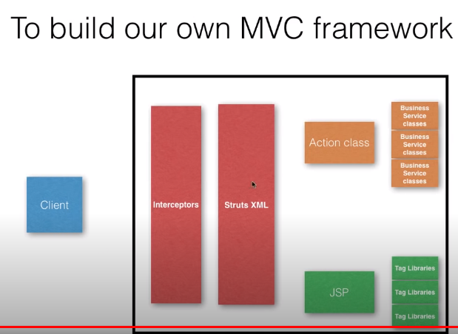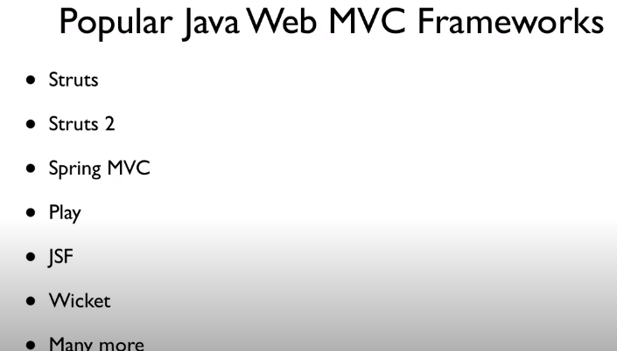

# Struts 2 Tutorial 02 - Introduction to Struts 2

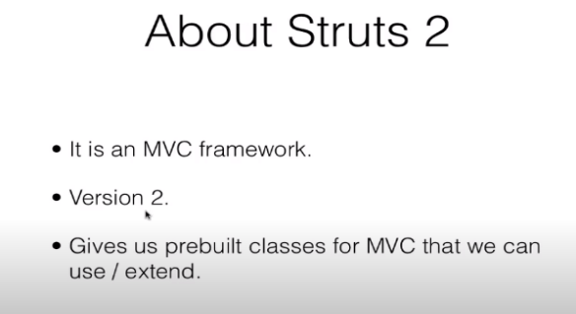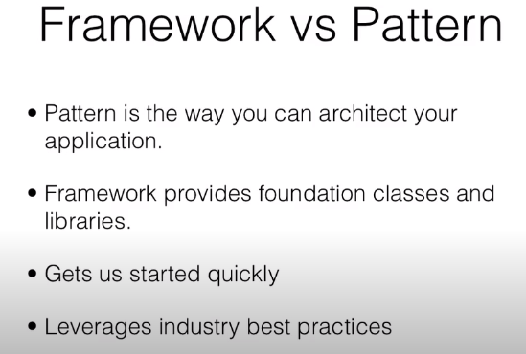

3 steps in Struts we need to do is

1. Write Struts xml
2. Write action class
3. Write JSP using struts tag libraries

<https://www.youtube.com/watch?v=LhjEgxJ080g&list=PLB7BB551126EDD5E0&index=3>

Open Eclipse🡪 new project🡪 web🡪 dynamic project

* Give project name, next
* Context root: StrutsStarter
* Content directory: Web
* Check Generate web.xml deployment descriptor
* Right click on project Properties🡺 Java Build Path🡪 libraries🡪 add Libraries--> user Library🡪
* User libraries🡪 create new name struts2🡪 click ok🡪 click external jar🡪 add jar from downloaded struts lib folder and save and apply.
* Got to project 🡪 java resources🡪 libraries 🡪 struts2.
* Take and Binding process.
* Right click on project🡪properties🡪 Deployment Assembly🡪 click Add🡪 java Build Path Entries🡪
* Next🡪struts2🡪finish🡪 click apply and save.

Interceptors are included default in Struts . We can configure and override the default setting.

**Three main components applications are ,Action Class, JSP and Struts 2 XML**

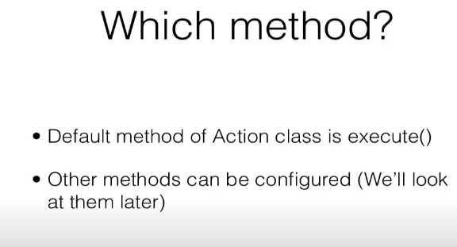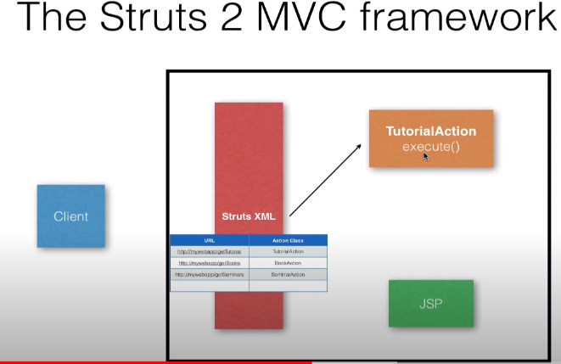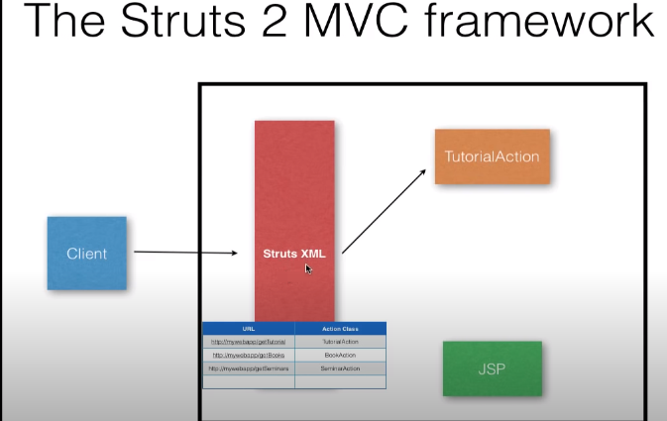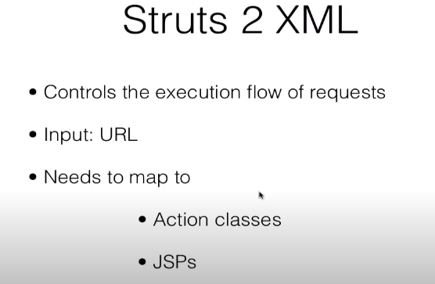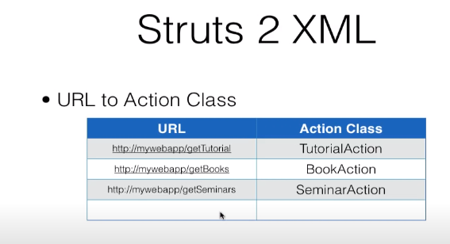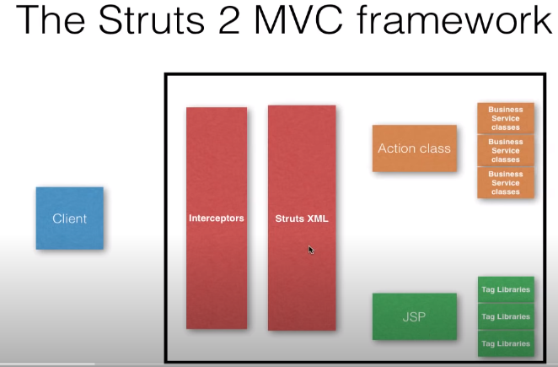

Mapping between action class and URL take place in between <struts> </struts>

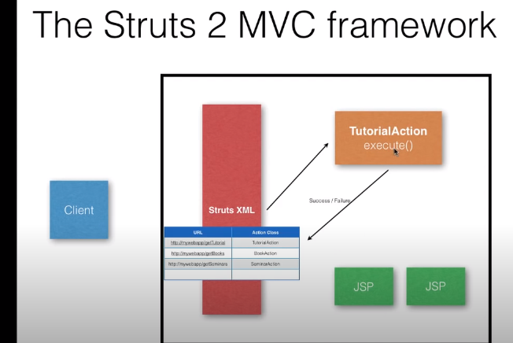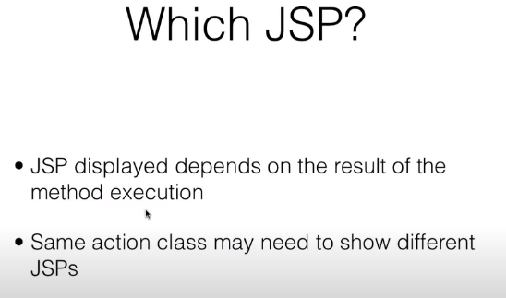

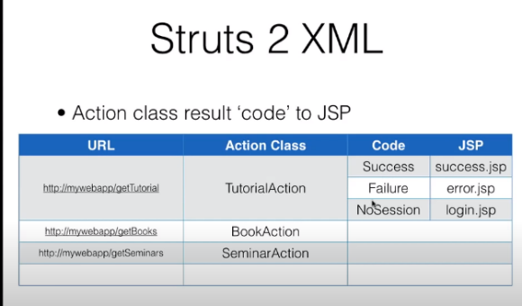

Whenever any input request TOMCAT looks for servlet in web.xml otherwise it will display error. We need to tell TOMCAT just to map struts. Do not try to look for servlet. For this we use filter in web.xml.

Filter Execute before all the servlet execute. Servlet is only look after filter.

StrutsPrepareAndExecuteFilter🡪 name of default filter class

<filter>

<filter-name>struts2</filter-name> <filterclass>org.apache.struts2.dispatcher.filter.StrutsPrepareAndExecuteFilter</filter-class>

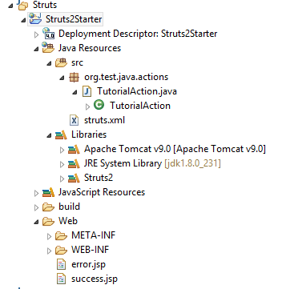 </filter>

This is for every request should pass through filter

<filter-mapping>

<filter-name>struts2</filter-name>

<url-pattern>/*</url-pattern>

</filter-mapping>

<http://localhost:8080/Struts2Starter/getTutorial.action>

.action is necessary with URL name.

**URL to action class to JSP**

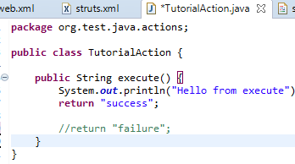**Simple struts application**

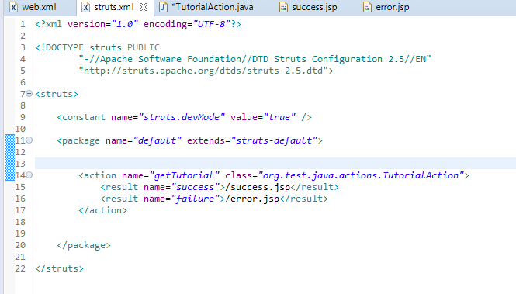

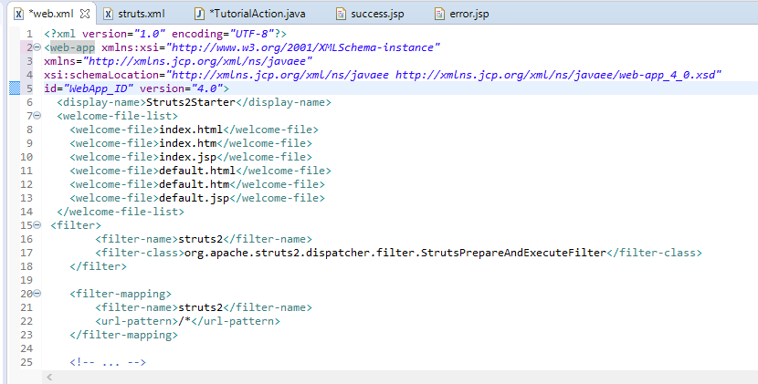

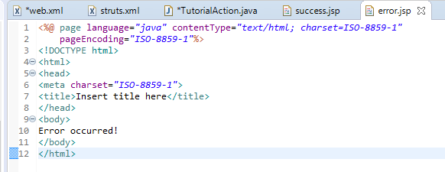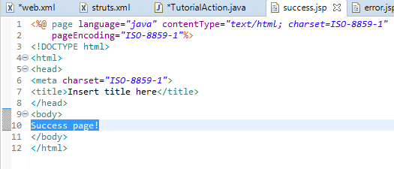

# Struts 2 Tutorial 05 - Understanding Namespaces

<http://localhost:8080/Struts2Starter/>

This displays the index.jsp

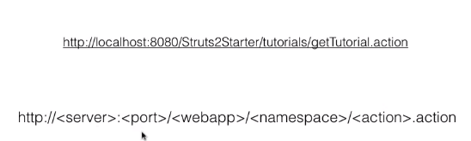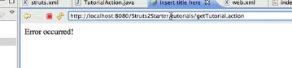Namespace is used to organized the URL into nested path

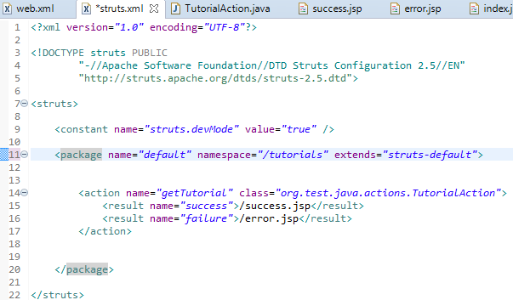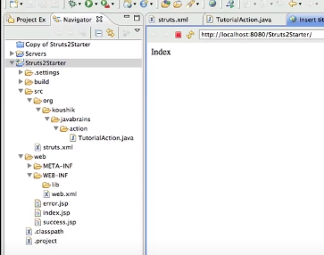

# Struts 2 Tutorial 06 - A Tag And A Business Service

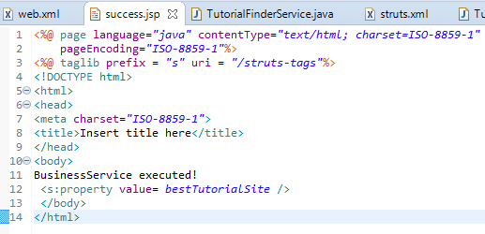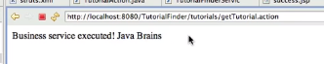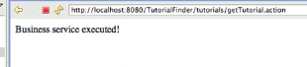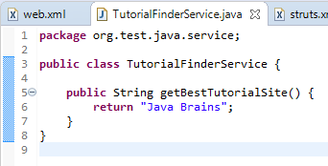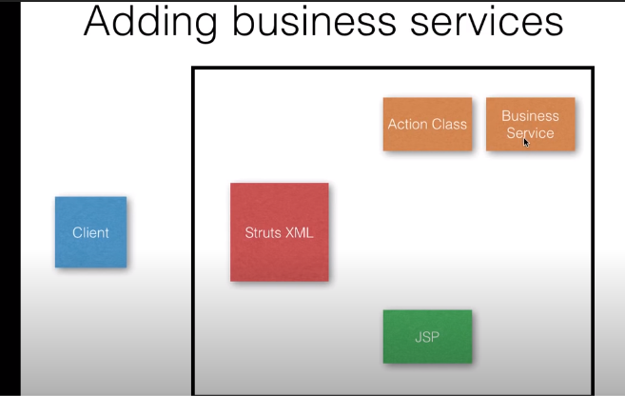

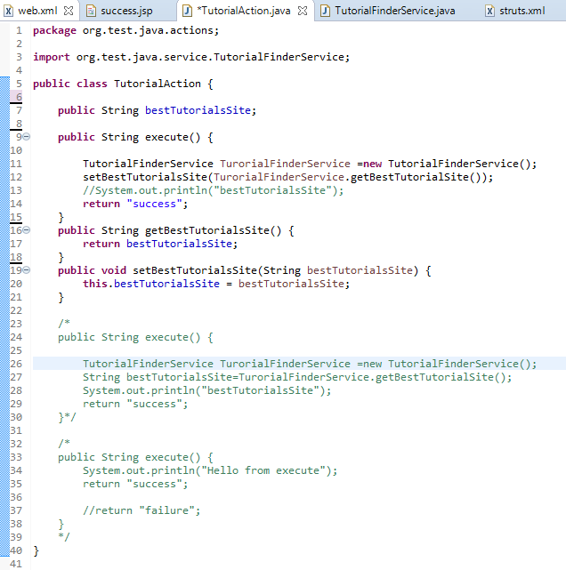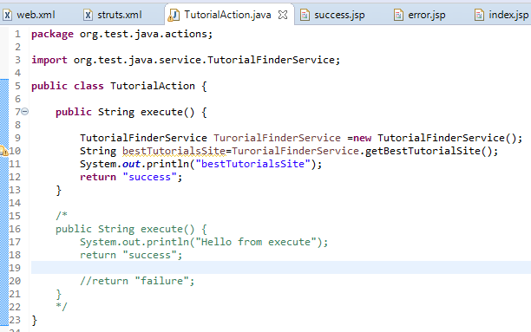

**Transfering data from Service layer to JSP page**

**In Success.Jsp**

<%@ taglib prefix = *"s"* uri = *"/struts-tags"*%>

<s:property value= *bestTutorialSite* />

# Struts 2 Tutorial 07 - The ValueStack

[**https://www.youtube.com/watch?v=EZpwBJ6EfDw&list=PLB7BB551126EDD5E0&index=8**](https://www.youtube.com/watch?v=EZpwBJ6EfDw&list=PLB7BB551126EDD5E0&index=8)

Tomcat create a 2 threads for two request instead of creating to servlet. New request object is created for each thread. Request object are accessible in JSP as well.

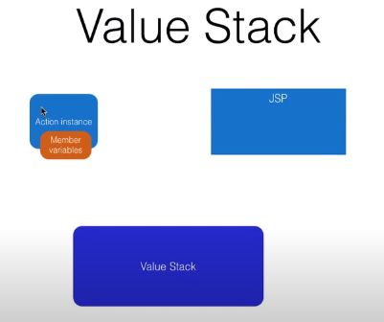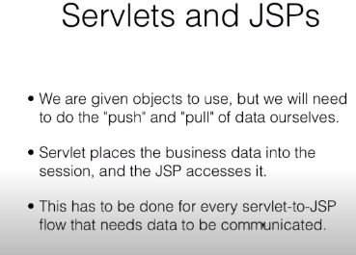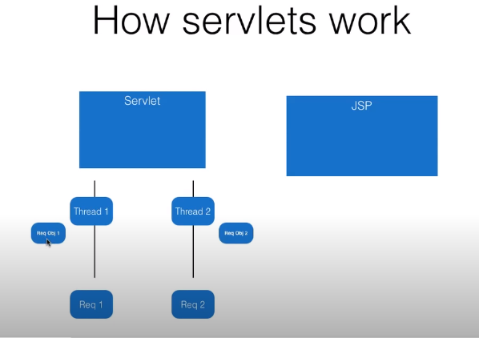

Two different object to transfer data that is 1) session and 2) request

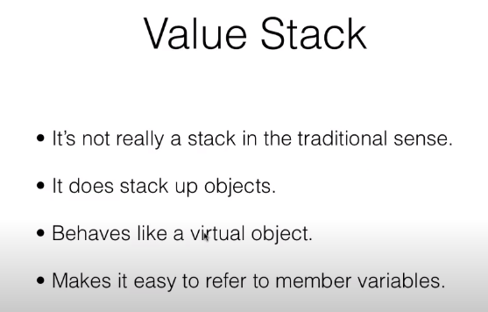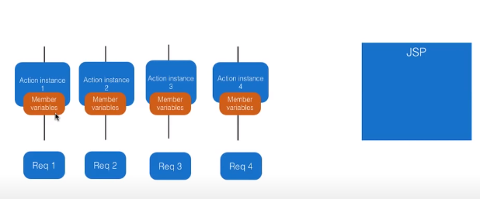

Value stack🡪

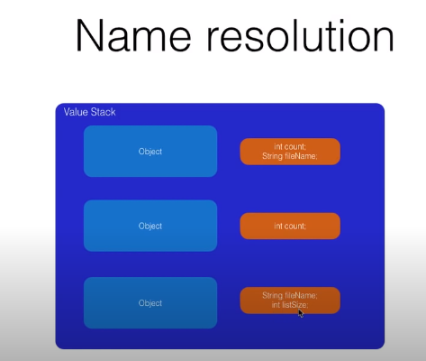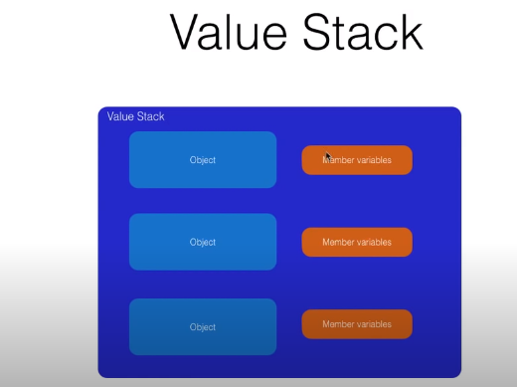Action Instance are save in value stack and JSp access Value stack.

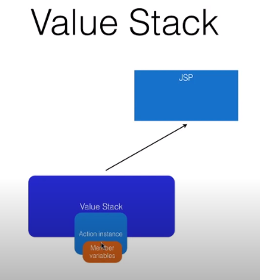

How Value stack handles Conflicts?

It checks by value stack. list Size and it sequentially check form top object to bottom for listSize.

# Struts 2 Tutorial 08 - Accessing Input Parameters

Data transfer between input request and action class is done by interceptors.

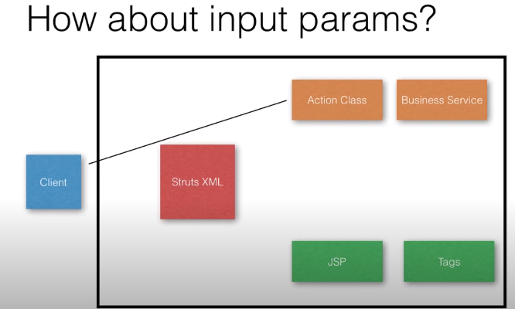



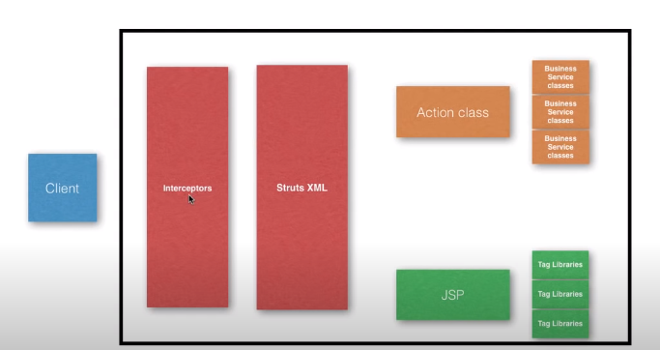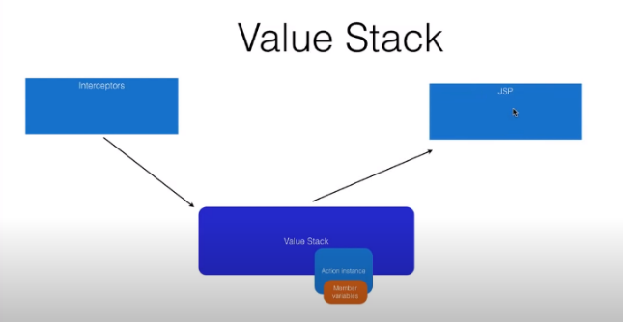Dotnet is printed in console

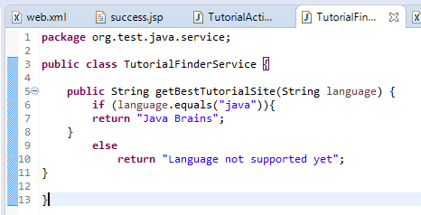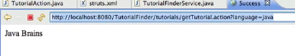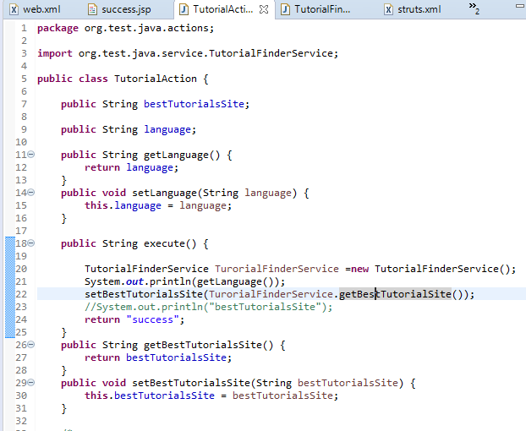

Data transfer between input request and action class is done by interceptors.

Language is a member variable, interceptors save the input language, then action access this value and does processing and save in output member variable and JSP access that value and print that value.

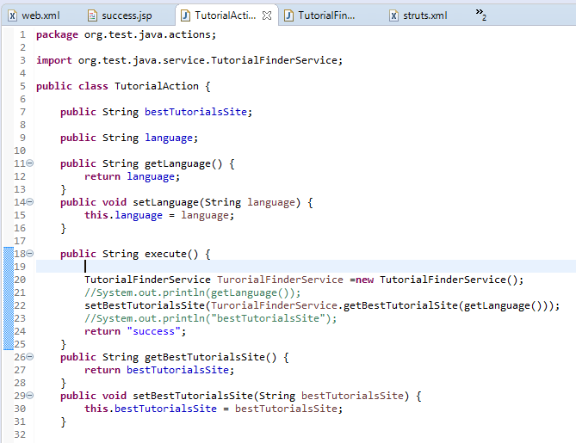

# Struts 2 Tutorial 09 - Post requests to actions

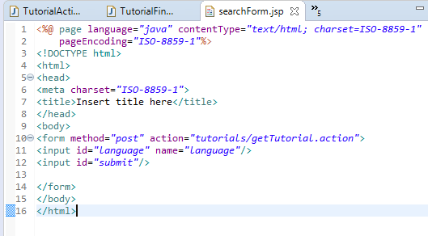This is another way of taking input parameters

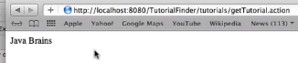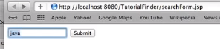

No replacing the HTML by its equivalent struts2 tags.

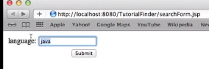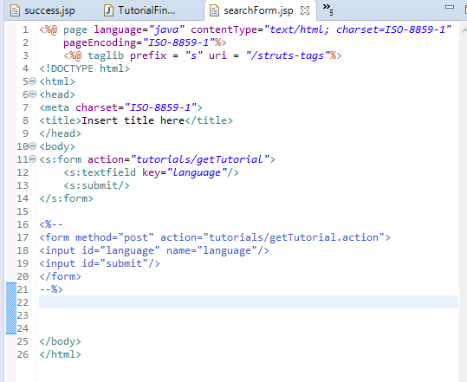

It is generating html form

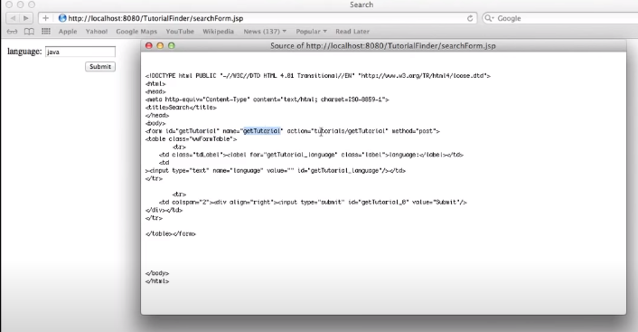

Change the label name on text field by putting label

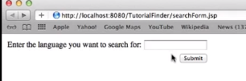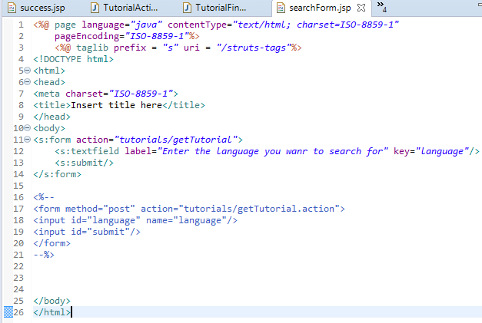

# Struts 2 Tutorial 10 - Login Action and Best Practices

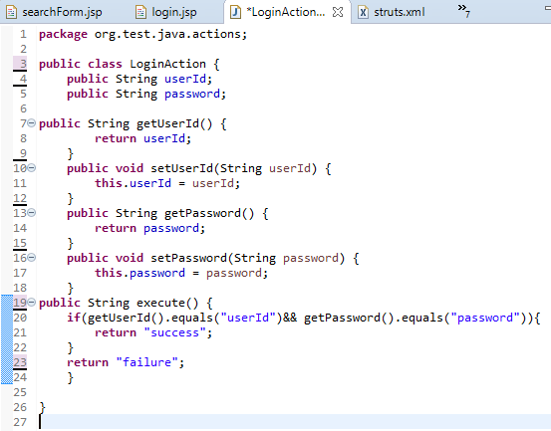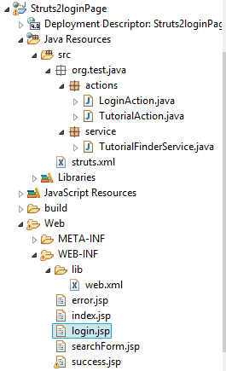

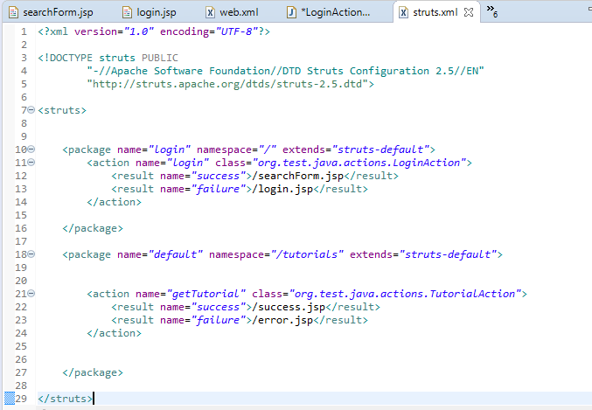

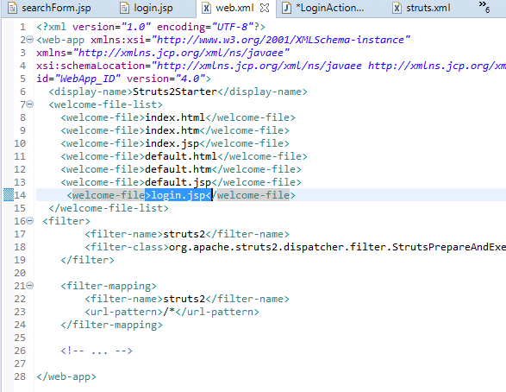

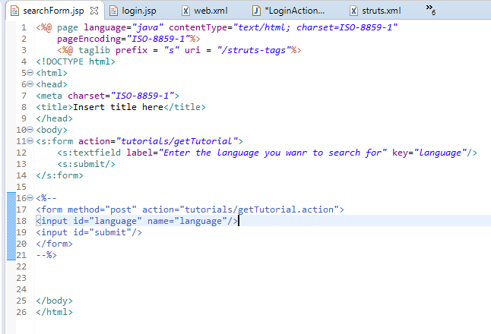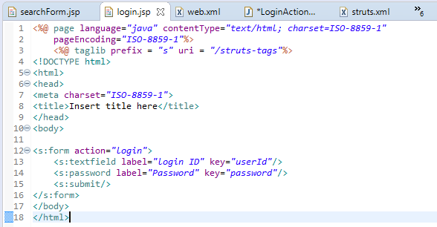

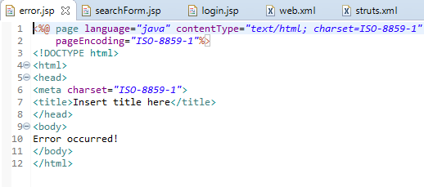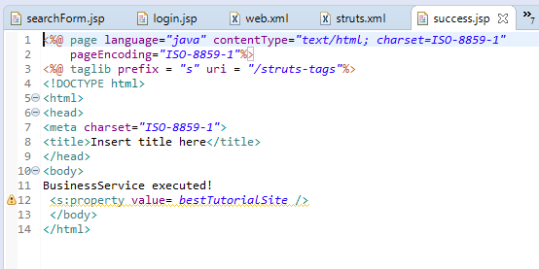

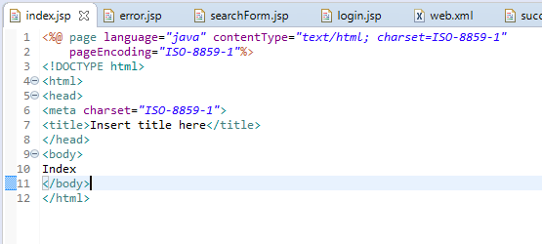

# Correct username and password redirect to searchForm.jsp

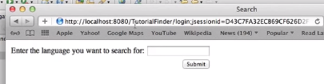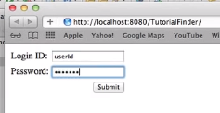

# InCorrect username and password redirect to login.jsp

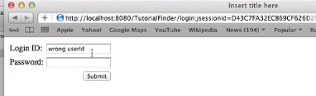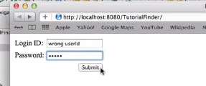

# Struts 2 Tutorial 11 - Login Action and Best Practices Part 2

# Implement Action class

# 

# 

# Success is changed to SUCCESS and failure is changed to LOGIN

# Splitting xml files (for more manageable)

# 

# Encapsulate your JSP link with dummy actions so that user sees the action not the JSPs that leaves you free to change names later if required.

# 

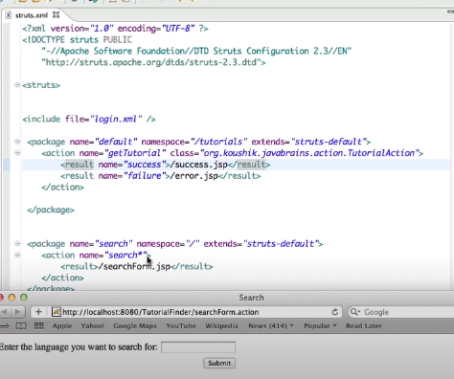

# Struts 2 Tutorial 12 - Action Wildcards

Search* will match everything that begins with search

Start from more specific ones because in below if it matches searchForm then it will redirect to searchForm.jsp otherwise searchTutorial.jsp. It start from top to bottom.

Can replace both action above with this this will match search(Form or Tutorial) in 1 place.

<action name=*"search*"*>

<result>/search{1}.jsp</result>

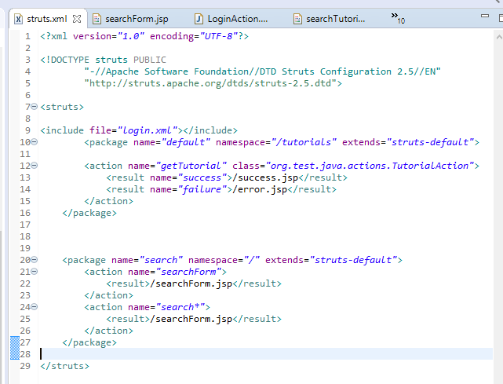 </action>

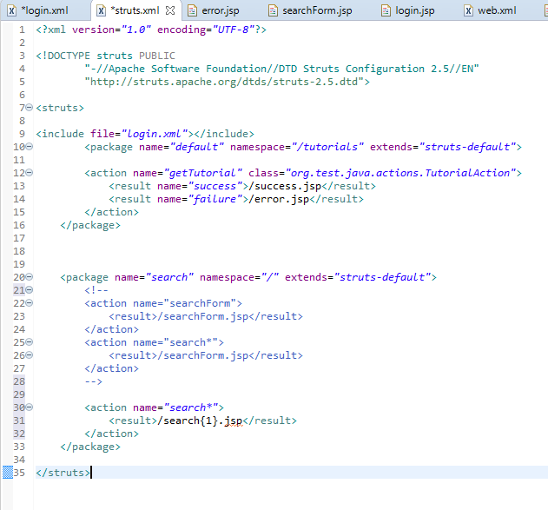Incase we have multiple action class we can do like that

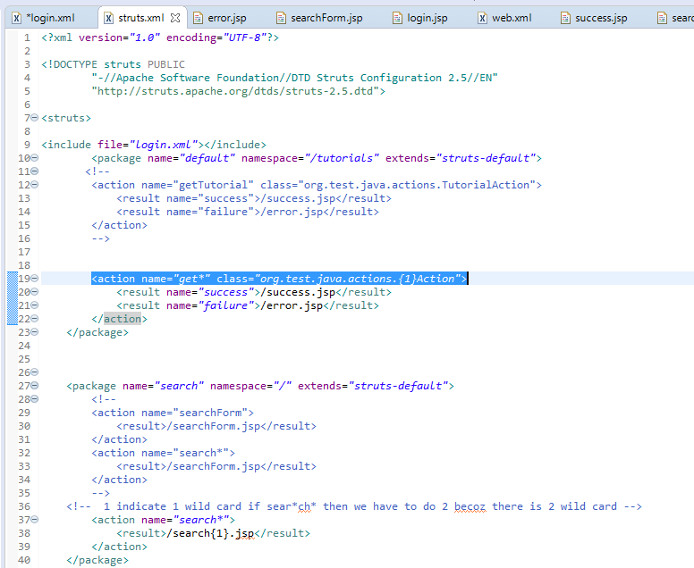

# Struts 2 Tutorial 13 - The ActionSupport Class

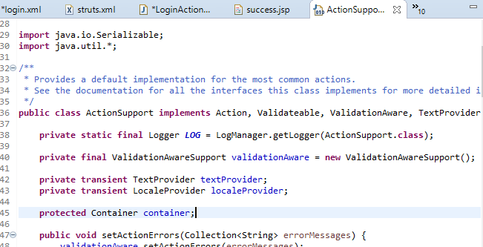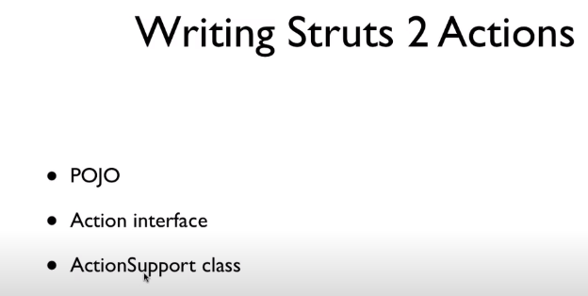

Action Support implements Action.

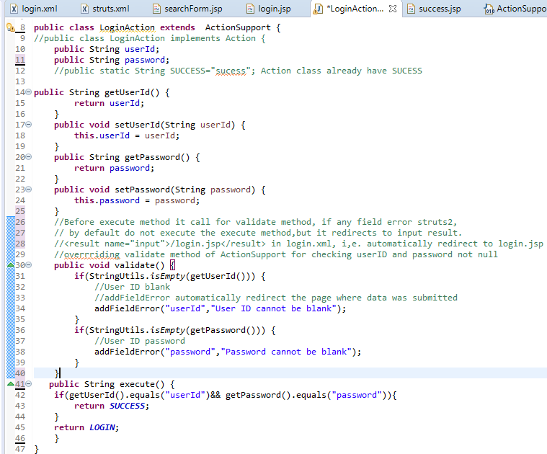

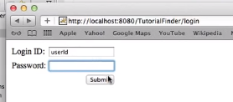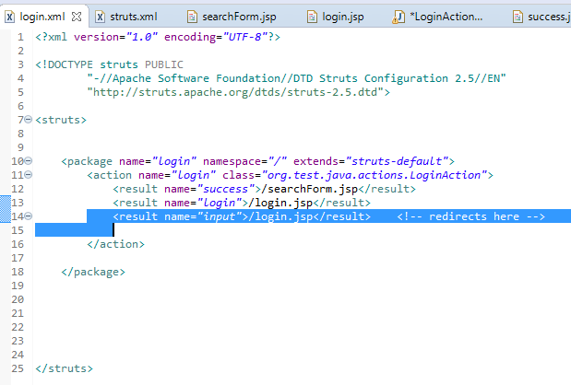

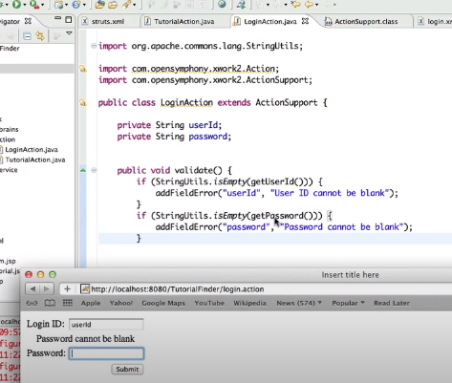If any input is blank it also displays field error.Action support implements these.

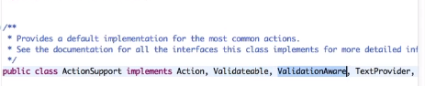

# Struts 2 Tutorial 14 - Configuring methods in Action mappings

When ever we do hget tutorial, method="someOthermethod" this method will get call.If this is not added it will excute the default method that is execute()

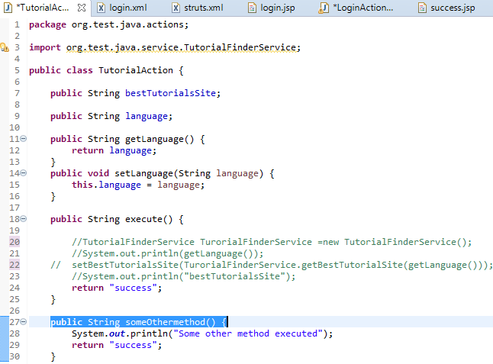

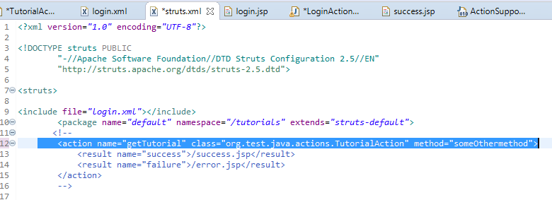

You can also do like this.

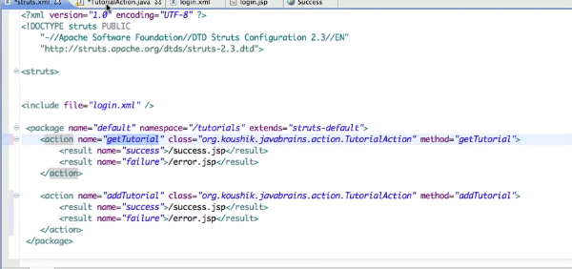

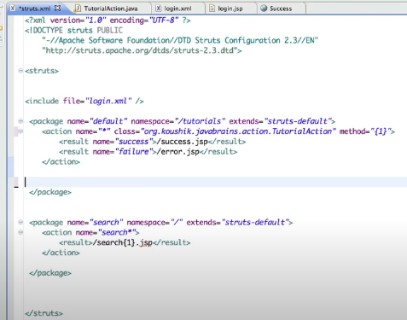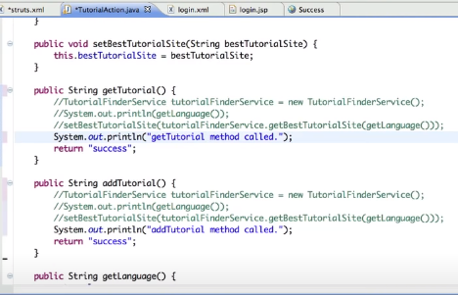

Or can also replace with wild card



# Struts 2 Tutorial 15 - Using Model Objects

# In we are creating separate model object that is User and separate service that is LoginService.

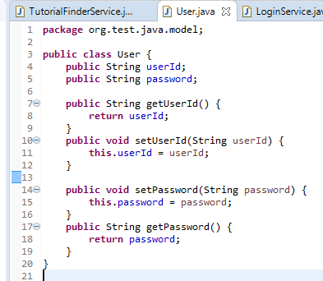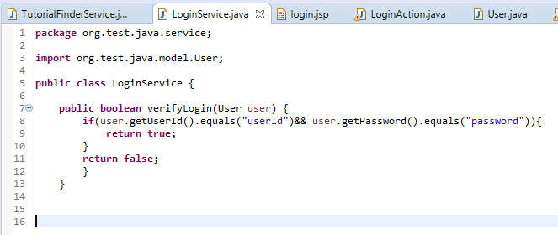

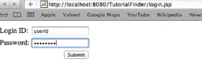

Another way is by using ModelDriven,

ModelDriven tells that your struts have model objects,you want stuts to help you to populate the model objects.

@Override

**public** Object getModel() {

// **TODO** Auto-generated method stub

**return** user;

}

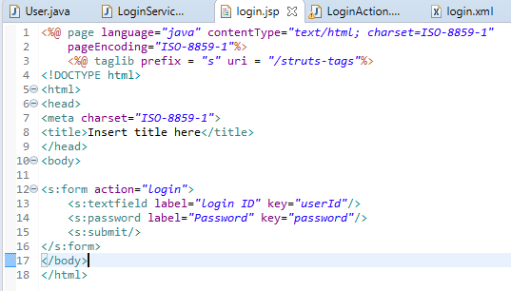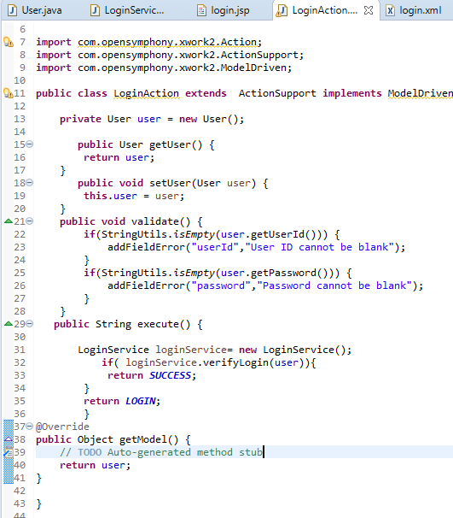

You don’t need to do user.userId and user.password when using ModelDriven

# Struts 2 Tutorial 16 - Introducing Interceptors

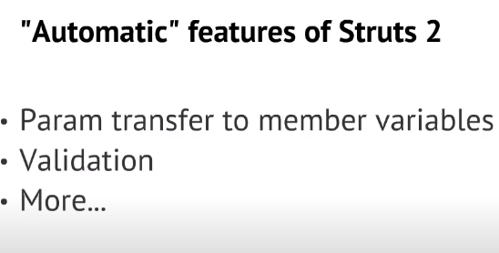

Who/What does this work? --> interceptors

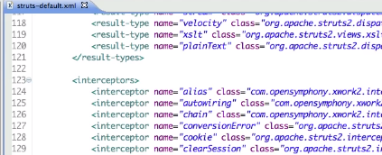Struts-default is inherited by default package.

Struts controller configured as filters that intercepts every request.

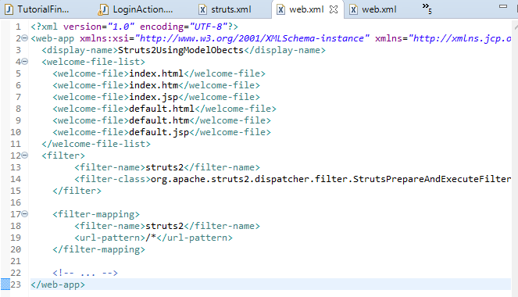

Struts2 is a cross cutting concern. It intercepts every request.

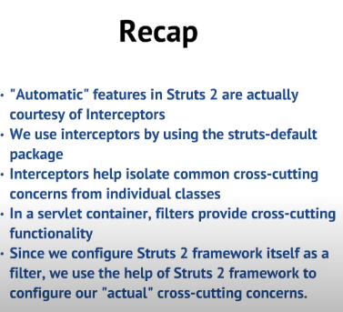

# Struts 2 Tutorial 17 - Configuring Interceptors

# 

# 

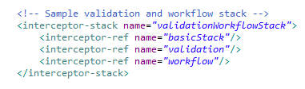

If you want to apply specific interceptor, eg <interceptor-stack name=*"paramsPrepareParamsStack"*>

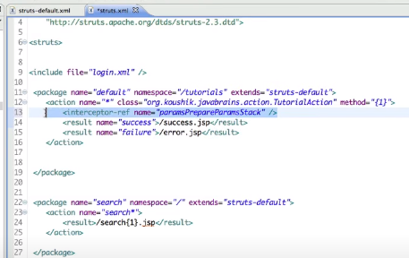Then type this in struts.xml

<interceptor-ref name=” *paramsPrepareParamsStack”/>*

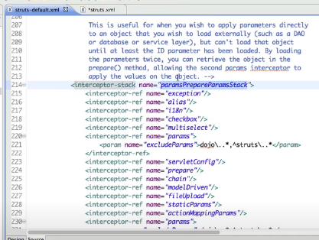

If interceptors are not specified it will take the default stack

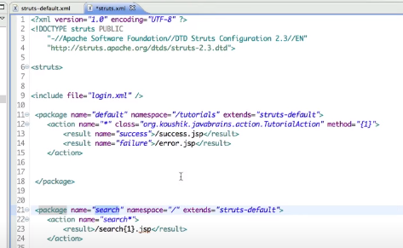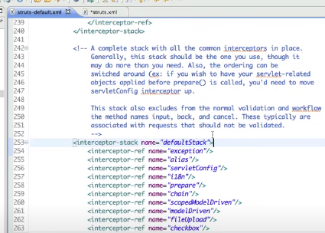

So in this case these both package are using defaultstack package.

# Struts 2 Tutorial 18 - Anatomy of an Interceptor

# 

